ECET 251 FINAL REPORT
  - Members: Faith Thurrott, Thomas Bourgeois, Andrew Goertzen
Instructor: Phil Vreugdenhil
Date: April 10th, 2026
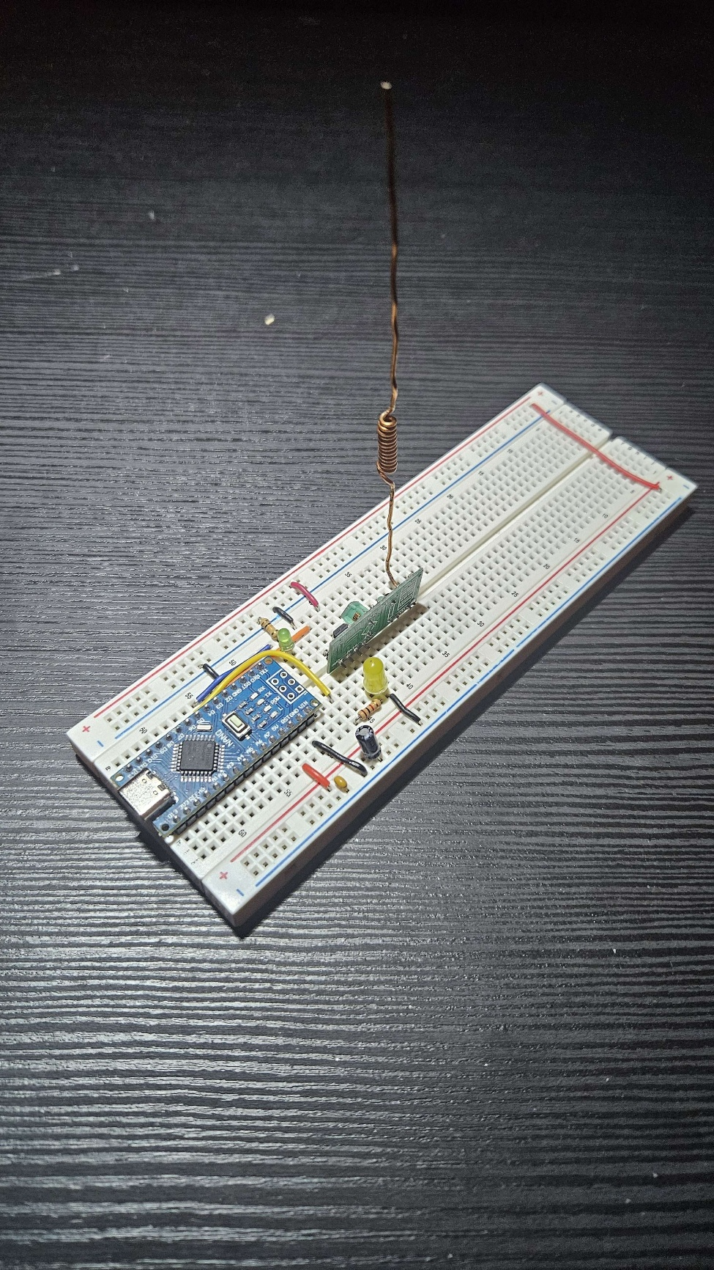
Figure 1: Receiver Circuit

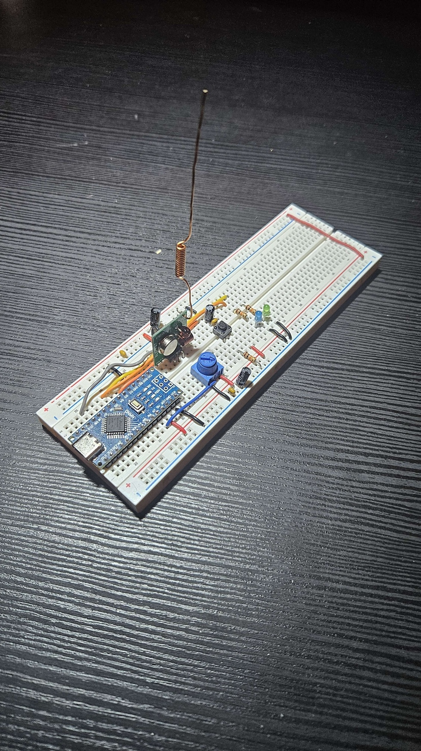
Figure 2 :Transmitter Circuit

Project Overview
- Create a wireless system using a microprocessor and TX, Rx modules
- Create a protocol for the system
- Test the communication system
- Document the system

Project GitHub Repo
https://github.com/Thomas1B/Digital_Communication_Final_Project

System Description
The following block diagram shows the overall structure of the system, including the main components and signal flow between the transmitter (Tx) and receiver (Rx). The dotted lines represent power, the dashed line represent wireless transmission, and the solid lines represent signals between components.
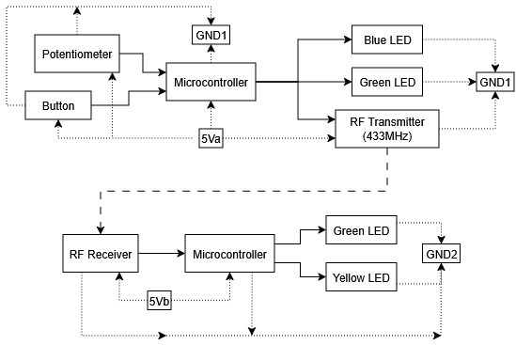
Figure 3 System Block Diagram
Note: 5Va, 5Vb, GND1, and GND2 are to signify that these two systems are powered separately. They can be power via the USB connection or the Vin pin of the microcontroller.
(5V and GND are the from the internal regulator of the controller).

Hardware Components:
This section lists the main hardware components used in both the transmitter and receiver circuits.
Table 1: BOM: Bill of Materials
Component | Quantity | Specification
Arduino Nano | 2 | 5V microcontroller board. Note 10-bit ADC and 8bit DAC resolution.
Transmitter Module | 1 | 433 MHz RF transmitter module
Receiver Module | 1 | 433 MHz Receiver module. 5Vdc.
Potentiometer | 1 | 10kΩ Pot. (Larger value gives more precision)
Button | 1 | Tactile switch. Rated voltage, 1-12Vdc.
Polarized capacitor | 4 | 10uF capacitance, 16V (min) voltage rating.
Capacitor | 4 | 0.1uF non polarized capacitor.
Resistor | 5 | 1 x 10kΩ, 4 x 1kΩ resistors,
LEDS | 4 | 1 Blue LED. 2 Green LEDs, 1 Yellow LED

Note: the capacitors are used for smoothing the button, pot, transmitter and receiver signals, so they are not necessary, but they can help with noise and debouncing. The 10kΩ resistor is used as a pull down resistor for the button, this should be 10kΩ at minimum. The 1kΩ resistors are used for the LEDs, these can be varied depending on what brightness is wanted, just note current draw cannot exceed 20mA in each LED. (always refer to datasheets)

Transmitter
The transmitter side is designed to read a potentiometer value and send it to the Rx using Manchester encoded communication. The potentiometer value is read from analog pin A7, and when the button on pin 3 is pressed, a 3 8-bit byte message is created. The first byte contains the message length, the second byte contains the mapped potentiometer value (since the ADC reads 10bits and the receiver can only transmit 8 bits bytes, also the DAC is only 8bits too), and the third byte contains a checksum for error detection. The checksum is calculated by adding the first two bytes before transmission. The data is then sent to the TX module using pin 9 at a data rate of 300 baud. A green LED indicates when the system is on and ready to transmit, and a blue LED flashes after a message is sent. A timing delay is used so the transmitter does not repeatedly send messages too quickly.

Receiver
The receiver side uses Manchester decoding to decode the received 3 8bit byte message through the RF receiver connected to pin 2. The first two bytes contain the transmitted data, and the third byte is used as a checksum for error detection. When a transmission is complete, the code stores the bytes in a buffer, prints the received values to the serial monitor and checks whether the calculated checksum matches the received checksum. If the checksum passes, the system counts it as a successful TX (otherwise ignore it and restart the loop) and uses the second byte to control the brightness of the LED on pin 5 using PWM. A green status LED on pin 4 is used to show the receiver activity, turning off briefly when the message is received being processed, then turning back on when ready for the next message.

Flowcharts
The following flowcharts shows how the software works for both the transmitter and receiver. All the code was written by Thomas and Faith, with the exception of the Manchester protocol library, that was provided by the instructor.

Transmitter Hardware Flowchart

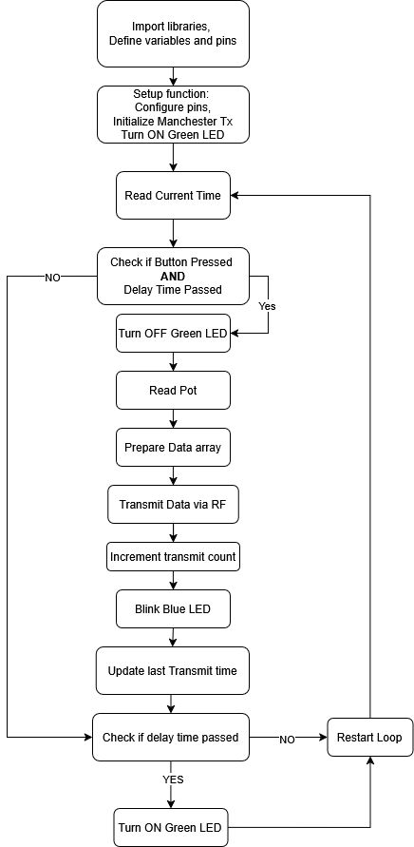
Figure 5 Transmitter Software Flowchart

Receiver Hardware Flowchart

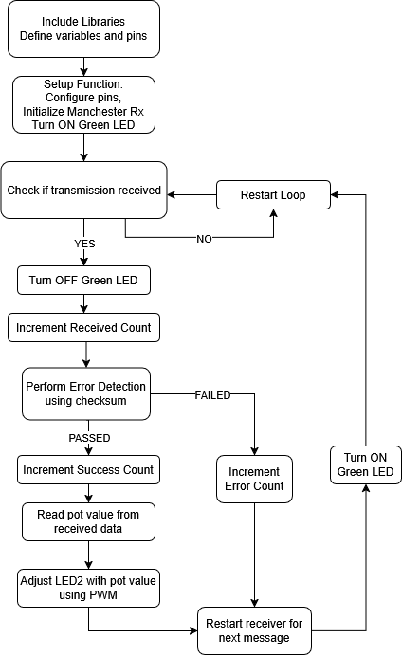
Figure 6 Receiver Software Flowchart

Calculations
This section shows the calculations used to evaluate the system’s performance, including EIRP, minimum electric field at the receiver, and bit error rate (BER).
EIRP of TX:
$$dBm=10\log_{10}\left(\frac{P_{sig}}{1mW}\right)→{10}^{\frac{49.69}{10}}*1mW=10.74nW$$
$$V=\sqrt{P*R}=\sqrt{10.74nW*50Ω}=732.8µV \\ dB=20\log_{10}\left(\frac{732.8µV}{1µV}\right)=57.3dBµV \\ EF\left(outside antenna\right)=57.3dBµV+0.29dBµV-17.1dBµV)=40.49dBµV \\ EF={10}^{\frac{40.49}{20}}*1µV=105.8µV/m \\ EIRP=4πR^{2}*\frac{EF}{Z}=4π{\left(3m\right)}^{2}*\left(\frac{105.8µ\frac{V}{m}}{377Ω}\right)=3.36nW$$
Minimum EF at receiver:
$$EF=\sqrt{\frac{EIRP*Z}{4πR^{2}}}=\sqrt{\frac{3.36nW*377Ω}{4π3.35m^{2}}}=94.7µV/m$$
Bit Error Rate:
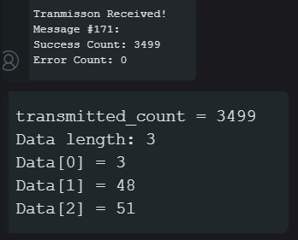
Figure 7: Serial monitor screen capture.
$$BER=\frac{1}{3499}=0.00028\%$$

Data Table
The key system parameters and measured values are summarized in Table 1 below.
Bandwidth | 1250Hz
Range limit | 11ft
Min EF at Receiver | 97.4mV/m
Carrier Frequency | 433MHz
Data Rate | 300 Baud Manchester Encoded
Data Format | potentiometer: 16bit,  Transmitted data: 2x8bits,  Received data: 2x8bits
Operating Voltages | 5 Volts
Power levels | 2.5 Watts
EIRP | 3.36nW
BER | 0%

Spectrum Analyzer Capture
The following figure shows the frequency spectrum of the transmitted signal as measured using a spectrum analyzer.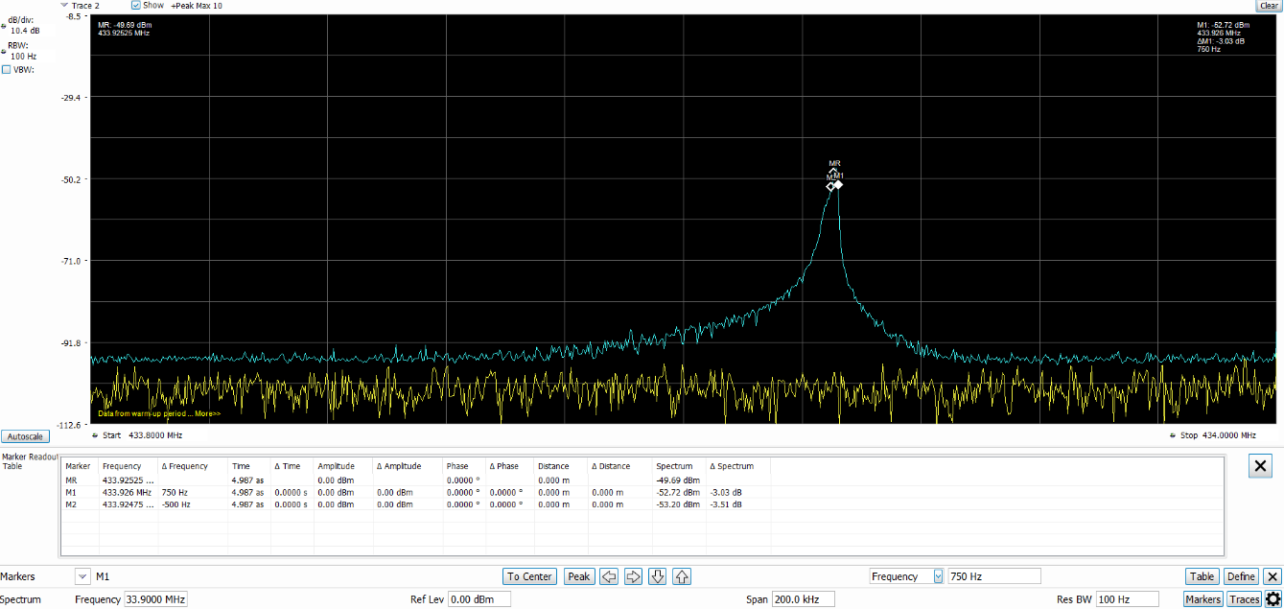
Figure 8:Spectrum Analyzer capture with data graph.

Manchester Encoded data packet
The following figure shows the Manchester-encoded data packet, including the structure of the transmitted signal.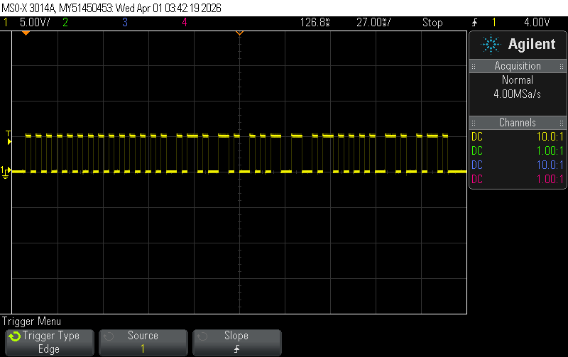
Figure 9: Oscilloscope capture of Manchester encoded data packet.

Setbacks and Obstacles
During the development of this project, the main issue we encountered was with the transmitter and receiver modules not reliably communicating with each other.
Initially, the system could not establish a consistent wireless link, even though both the transmitter and receiver were powered and functioning individually. This suggested that the issue was related to the RF modules themselves rather than the microcontroller or code.
To resolve this, we replaced the transmitter and receiver modules with a different set. After making this change, the system was able to successfully transmit and receive data as expected.
Aside from this hardware compatibility issue, the rest of the system functioned as intended with minimal problems. This highlighted the importance of using compatible and reliable RF components in wireless communication systems.

